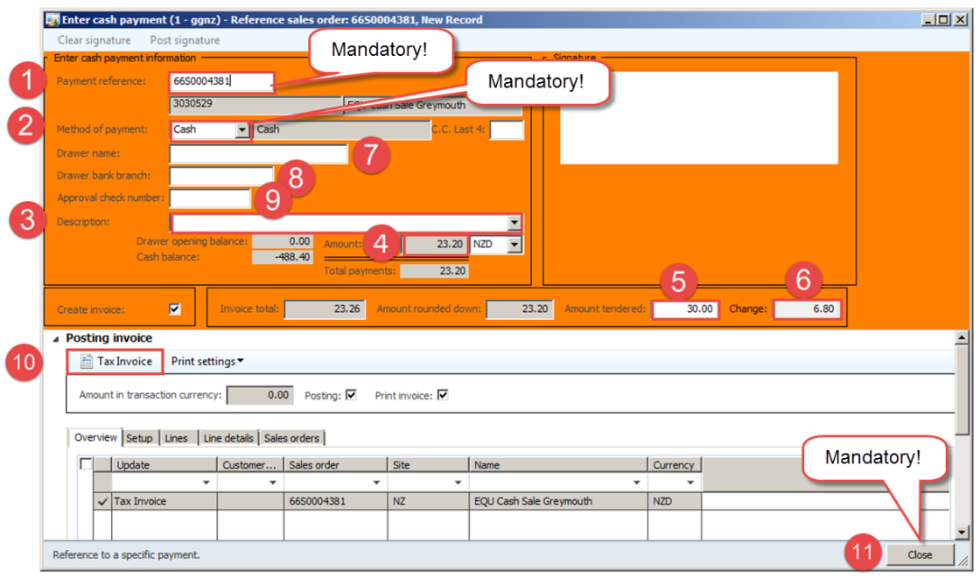**NAXT Quick tips**

**Filling in the cash sale screen - Cash**

*From Sales order, go to Sell > Cash register > Cash register payment type*

Select the Payment type code and click OK.

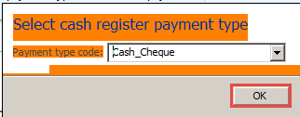

1. **Payment reference**: **Mandatory!** enter payment method or sales order number

* CASH
* SO0062990

1. **Method of payment: Mandatory!** This must match Payment type code

* Cash

1. **Description: Enter reason if payment taken in advance:**
2. **Amount: *(displays the amount customer should pay)*** e.g. $23.30
3. **Amount tendered:** (optional for cash) Type cash paid here then press tab

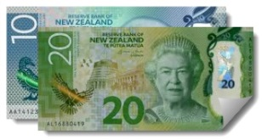e.g. $30.00

1. **Change: =** Amount - Amount tendered

e.g. $30.00 cash - $23.26 = **$6.80** **change**

1. **Drawer name:** n/a
2. 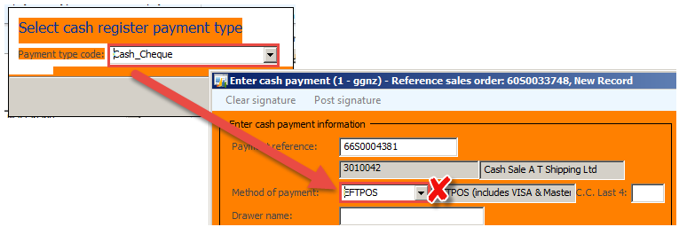**Drawer bank branch:** n/a
3. 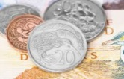**Approval cheque number:** n/a
4. **Tax Invoice:** Press this button when you have finished filling in form.

* **Invoice** will print – branch must give this to the customer.
* **Banking journal will be created**.

For more info see: ***FAR_2.12(SOP)Create and Manage a Banking Journal***

**11. Close: Mandatory!** You must press the **Close** button immediately or you’ll create unwanted extra work for accounts receivable staff.

If **Payment type code** does not equal **Method of payment**, do not press **Tax Invoice!** Press Close button and start again.

e.g. Cash_Cheque + EFTPOS = X

e.g. Visa_Mastercard_EFTPOS + EFTPOS = ☺